Ideation Phase
Brainstorm & Idea Prioritization Template

Date | 29-11-2025
Team ID
Project Name | DocSpot- Doctor Appointing Booking System
Maximum Marks | 4 Marks

Step-1: Team Gathering, Collaboration and Select the Problem Statement
Collaboration Process
Our team conducted a brainstorming session on 31st January 2025 to identify problems in healthcare appointment booking. Each team member contributed ideas, and we grouped similar problems together.
Team Members: 4 members (Project Lead, Designer, Developer, Database Admin)
Duration: 30 minutes
Problem Statement
Patients struggle to book doctor appointments due to inefficient manual systems. They face long phone wait times, no real-time availability, and forgotten appointments. Doctors experience scheduling conflicts, high no-shows, and wasted time. We need a digital system to streamline appointment booking for both patients and healthcare providers.
Key Challenges
Patient Problems:
- Long wait times on phone to book appointments
- Cannot see doctor availability in real-time
- No appointment reminders leading to missed visits
- Difficulty finding the right specialist
Doctor/Hospital Problems:
- Manual scheduling causes double bookings
- High no-show rates (25-30%)
- Administrative staff overloaded
- Poor patient record management
Project Goals
- Reduce booking time from 15 minutes to under 2 minutes
- Enable 24/7 online appointment booking
- Reduce no-shows by 40% with automated reminders
- Improve patient satisfaction

STEP 2: BRAINSTORM, IDEA LISTING AND GROUPING
Brainstorm
Our team brainstormed various features and functionalities for the Doctor Appointment Booking System.
All Ideas Generated:
- Patient registration and profile management
- Doctor profile with specialization and availability
- Real-time appointment booking system
- Search and filter doctors by specialty and location
- Email and SMS notification system
- Appointment reminders (24 hours before)
- Appointment history and tracking
- Calendar integration for patients and doctors
- Rating and review system for doctors
- Online payment integration
- Emergency appointment booking
- Video consultation feature
- Prescription management system
- Medical history tracking
- Admin dashboard for analytics
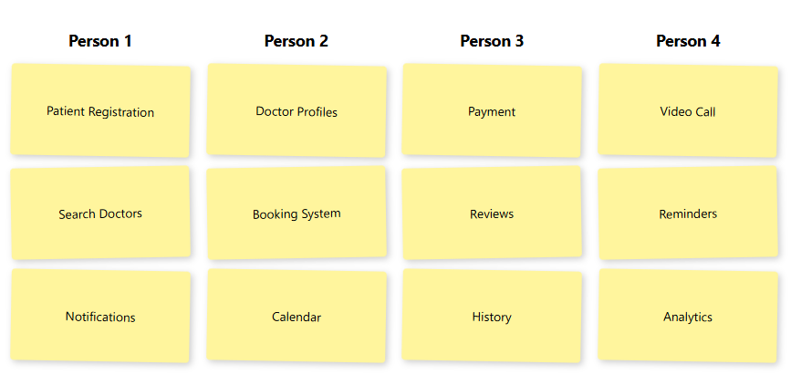
Idea Grouping
We grouped similar ideas into categories based on their functionality:
Group 1: User Management
- Patient registration and profile management
- Doctor profile with specialization and availability
- Admin dashboard for analytics
Group 2: Appointment Management
- Real-time appointment booking system
- Search and filter doctors
- Appointment history and tracking
- Calendar integration
- Emergency appointment booking
Group 3: Communication & Notifications
- Email and SMS notification system
- Appointment reminders
- Rating and review system
Group 4: Advanced Features
- Online payment integration
- Video consultation feature
- Prescription management system
- Medical history tracking
STEP 3: IDEA PRIORITIZATION
We evaluated each idea based on Impact (value to users) and Feasibility (ease of implementation).
HIGH PRIORITY (High Impact + High Feasibility)
These features will be implemented first:
- Patient registration and profile management
- Doctor profile with specialization and availability
- Real-time appointment booking system
- Search and filter doctors by specialty and location
- Email and SMS notification system
- Appointment reminders
MEDIUM PRIORITY
These features will be added after MVP:
- Appointment history and tracking
- Calendar integration
- Rating and review system
- Admin dashboard for analytics
LOW PRIORITY / LONG-TERM
These features are planned for future versions:
- Online payment integration
- Video consultation feature
- Prescription management system
- Medical history tracking
Final Selection for MVP
We will implement 6 high-priority features in the first version for maximum impact with available resources.

STEP 4: IMPLEMENTATION ROADMAP AND CONCLUSION
Implementation Plan
Based on our prioritization, we have created a phased implementation roadmap:
Phase 1: MVP Development
- Patient registration and login system
- Doctor profile management
- Real-time appointment booking
- Search and filter functionality
- Email/SMS notification system
- Basic user dashboard
Phase 2: Enhancement
- Appointment history and tracking
- Rating and review system
- Admin dashboard with analytics
- Calendar integration
- Improved UI/UX
Phase 3: Advanced Features
- Online payment integration
- Video consultation feature
- Medical history tracking
- Prescription management
- Mobile app development
Technology Stack
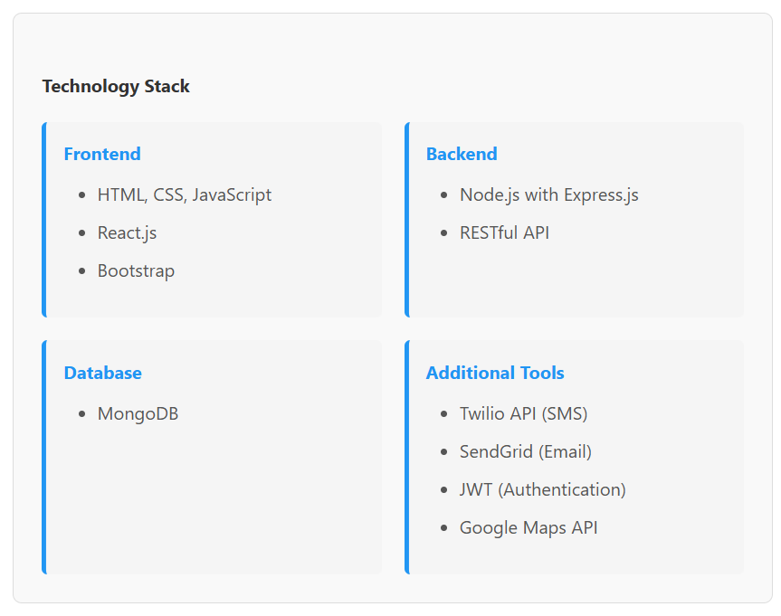
Frontend:
- HTML, CSS, JavaScript
- React.js
- Bootstrap for responsive design
Backend:
- Node.js with Express.js
- RESTful API architecture
Database:
- MongoDB for flexible data storage
Additional Tools:
- Twilio API for SMS notifications
- SendGrid for email notifications
- JWT for authentication
- Google Maps API for location services
Conclusion
The Doctor Appointment Booking System addresses critical challenges in healthcare appointment management. Through systematic brainstorming and prioritization, we identified 15 potential features and selected 6 high-priority features for the MVP.
Our phased implementation approach ensures we deliver core value quickly while planning for future enhancements. The system will benefit patients through convenient 24/7 booking, doctors through efficient schedule management, and healthcare facilities through reduced administrative burden.

